Assignment 2

For Password change to IneuROn#42

As it valid and strong password it will get changed

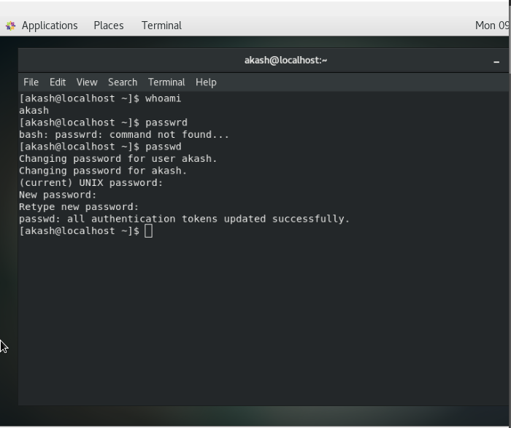

For Password change to 123 or abcd

As it is week and shot password, system will show error message as screenshot

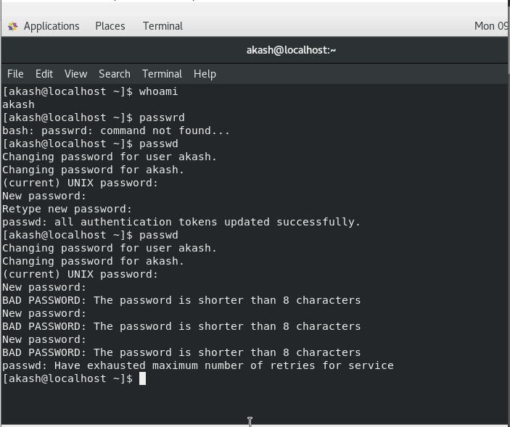

For no password

No input will lead to error, no password supplied.

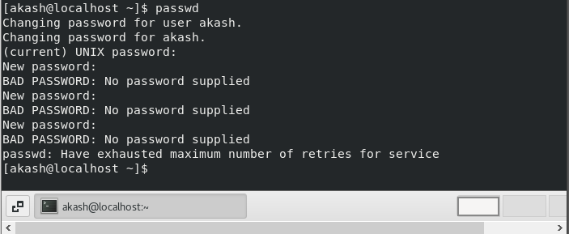

Assignment 3

1. 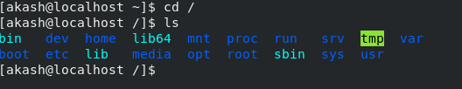

Cd / command change directory to root account

1. Cd /home show how many user present at home

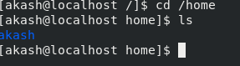

1. Cd .. move directory to 1 step back

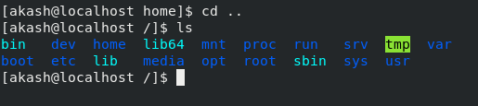

1. Cd /var/www/html no file or directory exist

And cd command move back to original directory

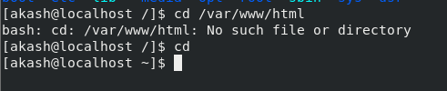

1. Cd /root moving to root account

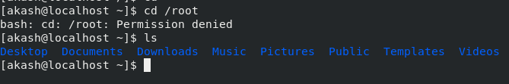

Assignment 4

1. Cd /etc move to etc file and ls will show all the file present under etc file

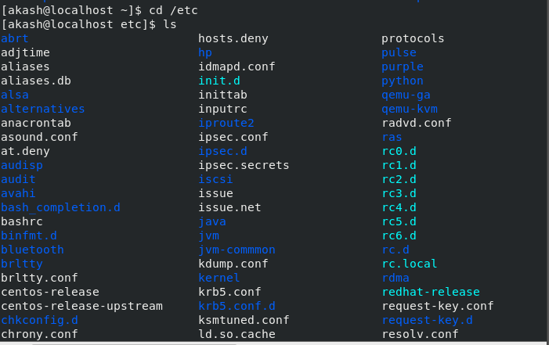

1. Ls –al show list of all file with Read, Write and Execute Permission

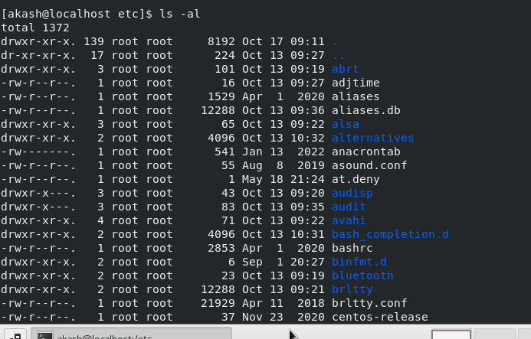

1. Ls –i it shows index number of all the files

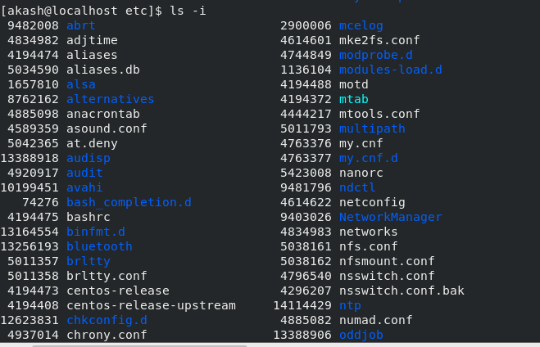

1. Ls –help show all different attributes that can be used to explore Linux system

Assignment 5

Pwd current directory

Cd with change directory

